ELEKS®

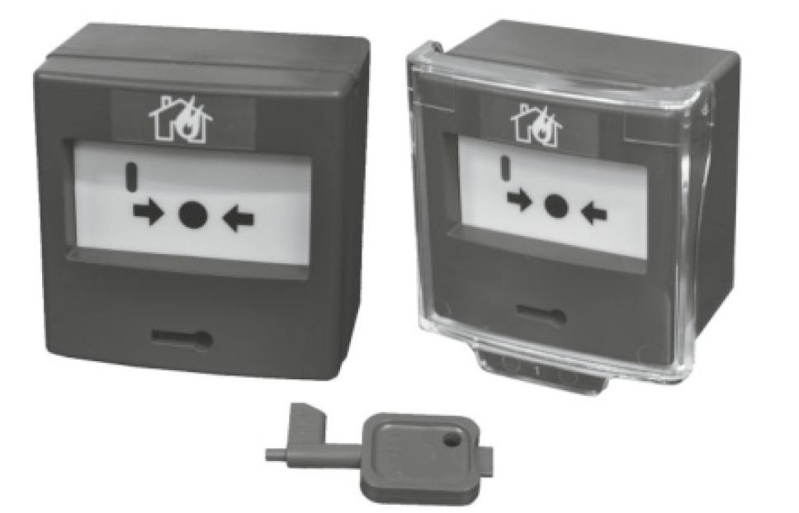

Nova Series Intelligent Addressable Manual Call Points User’s Guide
NOVA-AMCP
Intelligent Addressable Manual Call Point with Isolator
WARNING: PLEASE USE THIS INSTRUCTION CAREFULLY PRIOR TO OPERATING OR COMMISSIONING THIS DEVICE

Usage Purpose
Nova-AMCP is designed according to systems with reset feature, having EN54-11 and EN54-17 standards and by using Eleks protocol. It is used for manually arm the system in order to test any fire alarm or system. With the displaced glass, it is understood that the button is in the alarm position. The red LED indicator and the fire alarm system are activated by the contact output on the line where it is energized.

Technical Specifications
Product code | Nova-AMCP
Product Type / Category | Tip A / Closed Zone
Activation Signal | Red LED
Operating voltage | 24 VDC Tipical
Alarm Current | 2mA
Relative Humidity (Max.) | 95%
Heat | (-10⁰C) – (+55⁰C)
Weight | 121 gr.
Dimensions | 87x86x56 mm

- Mounting Instructions:
For Nova-AMCP, connect the cables coming from the line paying attention to the IN+, IN- OUT+, OUT- connections on the terminal.
If the IN and OUT connections on the line are not made correctly as in the manual, the isolator will not work properly.

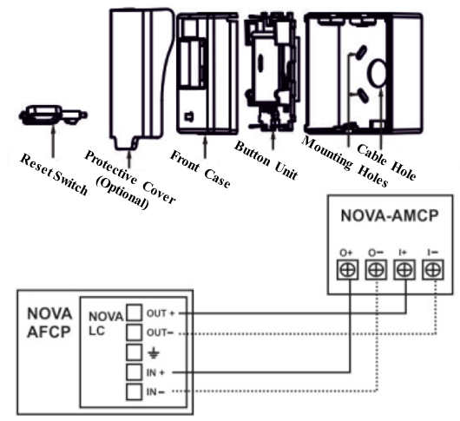
- Warnings
- Pay attention to the connection types of Nova-AMCP products.
- Do not supply the Nova-AMCP other than 24V DC.
- If a protection cover (Optional) is used, the protection cover must be removed to switch the button on.
- Periodic maintenance should be done once a year by an authorized service.
- Do not touch with wet hands.
- Protect against falls and impacts.
- It is recommended not to use the product in places where substances that can cause corrosion are concentrated.
- The warranty period is 2 (two) years.
- The useful life of the goods is 7 years.
TURKISH REPUBLIC
MINISTRY OF INDUSTRY AND TRADE OF PROTECTION OF CONSUMER AND COMPETITION
GENERAL DIRECTORATE
WARRANTY CERTIFICATE

Approval Date and Number of Document:
In the use of this document; Permission has been granted by the Republic of Turkey General Directorate of Protection of Consumer and Competition pursuant to the Law No. 4077 on the Protection of the Consumer and the Regulation on the Implementation Principles of the Warranty Certificate, which was put into effect on the basis of this Law.

MANUFACTURER / IMPORTER COMPANY
TITLE | : | Eleks Electric Electronic Systems Industry and Trade Limited Company
ADDRESS | : | Şerifali Region Bayraktar Avenue Emin Str. No:3 Yukarı  Dudullu - Umraniye / ISTANBUL
PHONE | : | 0216 463 47 28 -29 -30
FAX | : | 0216 463 47 31
COMPANY AUTHORITY
SIGNATURE-STAMP
THE PRODUCT’S

TYPE | :
BRAND | : | ELEKS
MODEL | :
BANDROLE AND SERIAL NO | :
DELIVERY DATE AND PLACE | :
WARRANTY PERIOD | : | 2 (TWO) YEARS
MAXIMUM REPAIR TIME  THE SELLER’S | : | 30 WORKİNG DAYS

TITLE | :
ADDRESS | :
PHONE | :
FAX | :
FAX INVOICE DATE AND NO | :
DATE-SIGNATURE-STAMP

Warranty Certificate
- The warranty period starts from the delivery date and is 2 (two) years.
- The entire product, including all parts, is under the guarantee of our company.
- In case of malfunction of the product within the warranty period, the period of repair is added to the warranty period. The repair period of the goods is maximum 30 (thirty) business days. This period starts from the date of notification of the goods to the service station, or to one of the seller, dealer, agency, representative, exporter or manufacturer, respectively, if there is no service station.
- In case of malfunction of the product due to material and workmanship or assembly faults within the warranty period, it will be repaired without any demand under any other name, such as labor cost, replacement part cost, or any other name.
- For this product
- From the date of delivery, within 1 (one) year, provided that it remains within the warranty period, the continuity of the inability to benefit from the product as a result of the same failure being repeated more than 2 times or different failures occurring more than 4 times,
- Exceeding the maximum time for repair,
- In case the service station is not available, in case it is determined that the repair of the fault is not possible with a report to be prepared by one of the dealers, dealers' agents, representatives, importers or manufacturers, respectively, a replacement will be made free of charge.
- Defects resulting from the use of the product contrary to the terms in the user manual are not covered by the warranty.
- For problems that may arise regarding the warranty certificate, they can apply to the Ministry of Industry and Trade, General Directorate of Protection of Consumer and Competition.
In the use of this guarantee certificate; Pursuant to the Law on the Protection of the Consumer No. 4077 and the Regulation on the Implementation Principles of the Warranty Certificate, which was put into effect on the basis of this law, T.R. Singing. Trade It has been prepared in accordance with the following documents obtained from the Ministry of the General Directorate of Protection of Consumer and Competition. Date 18.12.2007 Document No. 47086

AUTHORIZED SERVICE
MANUFACTURER / Headquarters Service

PRODUCER COMPANY / SERVICE CENTER
TITLE |  | Eleks Electric Electronic Systems Industry and Trade Limited Company
ADDRESS | : | Şerifali Region Bayraktar Avenue Emin Str. No:3 Yukarı  Dudullu - Umraniye / ISTANBUL
PHONE | : | 0216 463 47 28 -29 -30
FAX | : | 0216 463 47 31
E-mail | : | eleks@eleksyangin.com
Web | : | www.eleksyangin.com
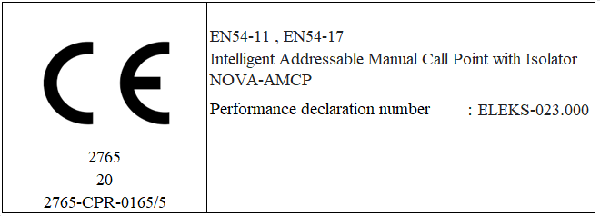

EN 54-11, EN54-17 Standards

