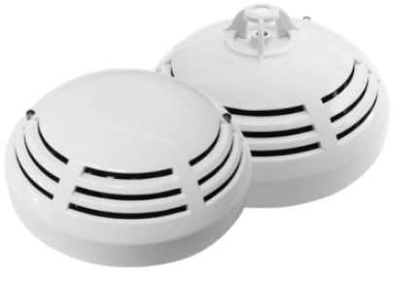

Nova Series Intelligent Addressable Type Fire Alarm Detectors
User’s Guide
NOVA-AHD
Intelligent Addressable Heat Detector
with Isolator
NOVA-ACP
Intelligent Addressable Combined Detector
with Isolator
NOVA-AOD
Intelligent Addressable Optical Smoke Detector with Isolator

WARNING: PLEASE USE THIS INSTRUCTION CAREFULLY PRIOR TO OPERATING OR COMMISSIONING THIS DEVICE

Usage Purpose
- Nova Series Intelligent Addressable Warning Detectors should be selected according to the class of fire that may occur and the characteristics of the building to be applied.
- As soon as the detectors are energized, it can be monitored that they are active with a red flash.
- The selection and commissioning of the mounting locations must be done by the authorized technical service.
- It should always be used with the same family of ADB Detector Base.

Descriptions of product codes (and type label colors)
AHD | : | Intelligent Addressable Heat Detector with Isolator (Factory setting is A2. It can be adjusted as A2-58⁰C / B-82⁰C / A2R - Temperature increase with software ORANGE.)
ACD | : | Intelligent Addressable Combined Detector With Isolator GREEN
AOD | : | Intelligent Addressable Optical Smoke Detector with Isolator

Technical Specifications
Supply voltage | 24V DC Typical
Tranquility Current* | 300 ± 10µA
Alarm Current | 2 mA
Alarm Signal | 200 mA for Parallel Warning Lamp
Start/Detection Time* | 9 sec
Power Indicator | Red LED (Short Flasher)
Alarm Indicator | Red LED (Constant)
Operating Temperature | (-10⁰C) – (+55⁰C)
Relative Humidity (Max.) | 95%
Weight: Product  : Socket | 100gr
 | 40 gr
Size** | Ø: 100mm , h: 60 mm

- Mounting Instructions:
PIL
PIL
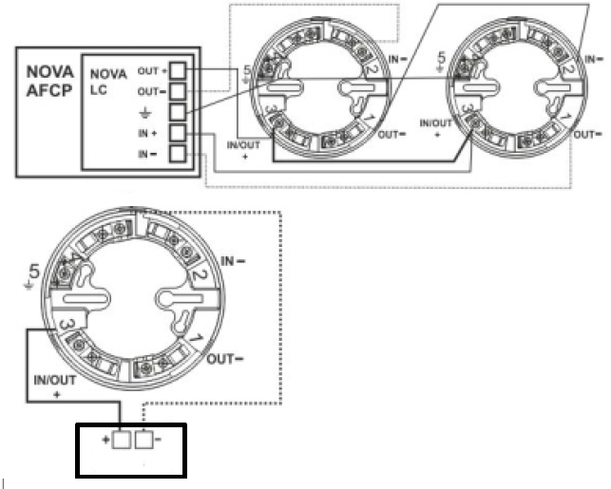
Socket - Battery Connection
Socket - Loop Connection
Battery

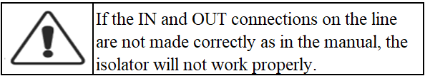
Installation must be done with ADB.

Table: Terminal connection located on ADB

Terminal 1 | : | (out-) | Terminal 2 | : | (in-)
Terminal 3 | : | (in/out+) | Terminal 4 | : | (Remote Indicator)
Terminal 5 | : | ( ↓ground)

- Warnings
Make sure the zone loop connections are correct. (Avoid contact with high voltage by connecting to the faulty line).
Make sure to perform Periodic Maintenance.
Call the authorized service for annual service.
Avoid contacting with water, dust and chemicals
Do not touch it with wet hands.
The plastic enclosure should remain attached until the product is ready for use.
The warranty period of the product is 2 (two) years.
The life of the product, as specified by the Ministry, is 5 years.
TURKISH REPUBLIC
MINISTRY OF INDUSTRY AND TRADE OF PROTECTION OF CONSUMER AND COMPETITION
GENERAL DIRECTORATE
WARRANTY CERTIFICATE

Approval Date and Number of Document:
In the use of this document; Permission has been granted by the Republic of Turkey General Directorate of Protection of Consumer and Competition pursuant to the Law No. 4077 on the Protection of the Consumer and the Regulation on the Implementation Principles of the Warranty Certificate, which was put into effect on the basis of this Law.

MANUFACTURER / IMPORTER COMPANY

TITLE | : | Eleks Electric Electronic Systems Industry and Trade Limited Company
ADDRESS | : | Şerifali Region Bayraktar Avenue Emin Str. No:3 Yukarı  Dudullu - Umraniye / ISTANBUL
PHONE | : | 0216 463 47 28 -29 -30
FAX | : | 0216 463 47 31

COMPANY AUTHORITY

SIGNATURE-STAMP
THE PRODUCT’S

TYPE | :
BRAND | : | ELEKS
MODEL | :
BANDROLE AND SERIAL NO | :
DELIVERY DATE AND PLACE | :
WARRANTY PERIOD | : | 2 (TWO) YEARS
MAXIMUM REPAIR TIME | : | 30 WORKİNG DAYS
THE SELLER’S

TITLE | :
ADDRESS | :
PHONE | :
FAX | :
FAX INVOICE DATE AND NO | :
DATE-SIGNATURE-STAMP

Warranty Certificate
- The warranty period starts from the delivery date and is 2 (two) years.
- The entire product, including all parts, is under the guarantee of our company.
- In case of malfunction of the product within the warranty period, the period of repair is added to the warranty period. The repair period of the goods is maximum 30 (thirty) business days. This period starts from the date of notification of the goods to the service station, or to one of the seller, dealer, agency, representative, exporter or manufacturer, respectively, if there is no service station.
- In case of malfunction of the product due to material and workmanship or assembly faults within the warranty period, it will be repaired without any demand under any other name, such as labor cost, replacement part cost, or any other name.
- For this product
- From the date of delivery, within 1 (one) year, provided that it remains within the warranty period, the continuity of the inability to benefit from the product as a result of the same failure being repeated more than 2 times or different failures occurring more than 4 times,
- Exceeding the maximum time for repair,
- In case the service station is not available, in case it is determined that the repair of the fault is not possible with a report to be prepared by one of the dealers, dealers' agents, representatives, importers or manufacturers, respectively, a replacement will be made free of charge.
- Defects resulting from the use of the product contrary to the terms in the user manual are not covered by the warranty.
- For problems that may arise regarding the warranty certificate, they can apply to the Ministry of Industry and Trade, General Directorate of Protection of Consumer and Competition.
In the use of this guarantee certificate; Pursuant to the Law on the Protection of the Consumer No. 4077 and the Regulation on the Implementation Principles of the Warranty Certificate, which was put into effect on the basis of this law, T.R. Singing. Trade It has been prepared in accordance with the following documents obtained from the Ministry of the General Directorate of Protection of Consumer and Competition. Date 18.12.2007 Document No. 47086

AUTHORIZED SERVICE
MANUFACTURER / Headquarters Service

PRODUCER COMPANY / SERVICE CENTER
TITLE |  | Eleks Electric Electronic Systems Industry and Trade Limited Company
ADDRESS | : | Şerifali Region Bayraktar Avenue Emin Str. No:3 Yukarı  Dudullu - Umraniye / ISTANBUL
PHONE | : | 0216 463 47 28 -29 -30
FAX | : | 0216 463 47 31
E-mail | : | eleks@eleksyangin.com
Web  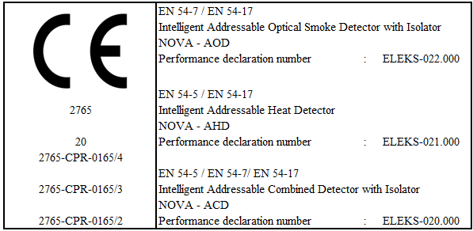 | : | www.eleksyangin.com

THİS PRODUCT HAS EN54-5,EN54-7,EN54-17 STANDARTS

